SOFTWARE REQUIREMENTS SPECIFICATION
RFID Parking Garage
Anthony Nichols
Matthew Nichols

1.0 Introduction
Finding parking spaces for automobiles and motorcycles can a problematic venture due to limited space and time, while the selling of parking spaces is potential lucrative endeavor. Currently, most large parking garages, including airport parking, use a ticketing system in which users get a time-stamped ticket when entering the structure and pay a time relative fee when exiting. The transmission of these disposable tickets is a time inefficient process susceptible to error. These tickets can easily be lost, and with the lost tickets, the entire process disoriented. The manual payment process can also be time consuming when traffic is at a high rate.
An RFID parking system would improve this by allowing the user to interact with the parking area with an RFID card at the entrance and exit of the parking area. An RFID parking system would also allow the user to keep an account on which the system would keep track of financial transactions. This would reduce the amount of time the user must interact with the system and increase the security of the user. A new system to allow ease of use and increased security of parking areas is needed
  - Goals and objectives
- To provide individuals who require a parking area with a system that is efficient and easy to use.
- To provide individuals with a system that accounts for the length of each visit and provides them with an account on which that can pay for the visit.
- To determine the adaptability of an RFID parking system with different situations
- To determine the feasibility and cost effectiveness of an RFID parking system that provides efficiency and ease of use.
- Improve security over convention RFID parking systems by adding a keypad

1.2 Statement of scope
A description of the software is presented. Major inputs, processing functionality and outputs are described without regard to implementation detail.
1.3 Software context
In order to resolve the issue, we must change the way that both that customers access the parking garage and how money is transferred between the building owner and the customer. A simple and accessible technology like Radio Frequency Identification (RFID) cards and readers could be taken advantage of in order to streamline the entry and exit process. The cards would be tied to customer accounts to which money could be transferred using a web interface. This new process would grant users virtually immediate entry and exit from the parking structure, while the garage owner would seamlessly receive correct payment. The process would begin by the user requesting an account through the web interface. This web interface will need to be easy to understand and navigate. After creating an account and receiving their unique RFID card in the mail, the user could add money to their account to be used as payment in the parking garage(s) connected to the system. As a user vehicle passes the RFID reader at a garage entrance, their card would be read in order to retrieve account information. If the account balance was above the required minimum, the vehicle would be granted access. When leaving the garage, the RFID reader at the exit would read the user’s RFID card and remove an appropriate amount of money from the connected account. This process of entry and exit can be streamlined to avoid the lines associated with the current parking garage procedure. The system would be able to count the number of vehicles in the structure at any one time, and therefore, know the amount of free parking spaces, if any existed.

1.4 Major constraints
- The system development cost for the initial prototype should not exceed $400.
- The final sales cost should be competitive with other typing products and specialized numeric keypad devices that are on the market at the time of sale.
- The system should be designed for operation in the home, office, or classroom.
- The system should withstand periodic cleaning with a damp cloth and mild detergent.
- The system should not contain materials that are hazardous to the user.
- The system should maintain functionality when used repetitively by elementary school aged children.
- The system should not interfere with the operation of the personal computer to which it is attached.
- The system must comply with Part 15, entitled "Radio Frequency Devices" of Title 47 of the Code of Federal Regulations.
- The system keypad should be ergonomic in design so that the occurrence of repetitive stress injuries is minimized.
- The system must not expose the user to electrical shock.
2.0 Usage scenario
2.1 User profiles
- Administrators – these individuals oversee the parking garage and all of its aspect. They are responsible for maintaining prices, user issues such as payment problems, login issues, and general parking garage problems.
- Users – these individuals are the ones who use the parking garage system.

2.2 Use-cases
Although the RFID Parking Garage is a relatively complex system, its direct interaction with the user is relatively simple. The primary actors in this system are users, administrators, and the database. Users utilize this system to gain access to the parking garage and to access/change their account information. Administrators use the system to manage accounts and add users. The database contains all information about users and decides whether a user is cleared for entrance or not.
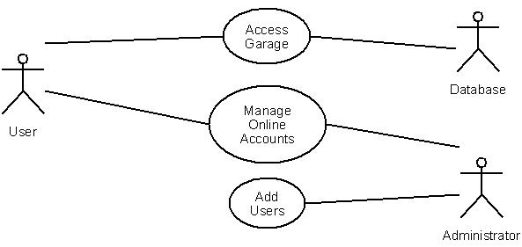 2.3 Special usage considerations
No special usage considerations needed.
3.0 Data Model and Description
3.1 Data Description
The objective of the RFID Parking Garage System is to allow users of the system a fast and convenient way in which to park their vehicles. The system will provide users with an RFID card and a graphical user interface from which to interact with the system. The RFID card is used at parking lots with this system to swipe their card and gain immediate access to a parking space. The user interface will allow users to check account information and additionally make payments to their account. The level zero functionality of the RFID Parking Garage System is illustrated in Figure 1. A summarized description of the level zero functionality follows in a table.
3.1.1 Data objects
- RFID Card Swipe – input from the user to the system
- Password Entry – input from the user to the system by a keypad
- Red/Green Light – indicator for the user of the system that notifies the user if they have access
- Admin/User Login – An Admin or user logs into the web interface
- Data Request – A data request made by the admin or user of the system on the web interface
- Data Response – Data that is sent to the admin or user of the system
3.1.2 Relationships
Relationships among data objects are described using an ERD- like form. No attempt is made to provide detail at this stage.
3.1.3 Complete data model
3.1.3.1 Level 0
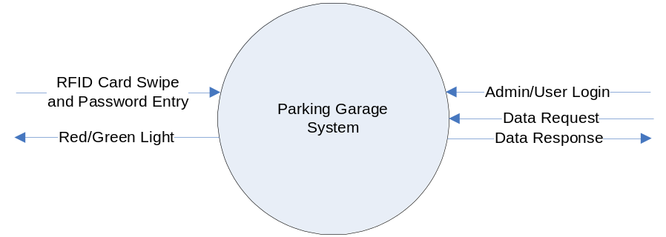

3.1.3.2 Level 1
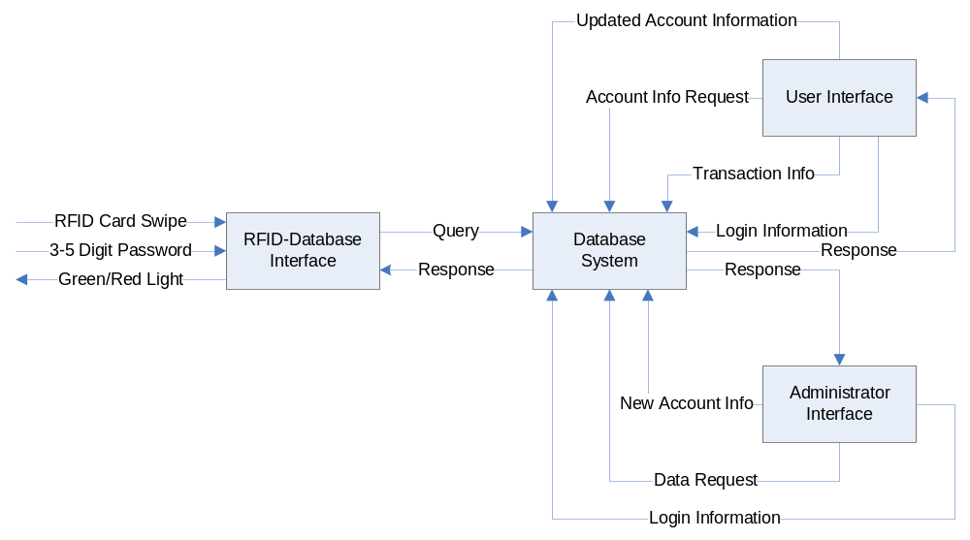
3.1.4 Data dictionary
- Admin - Administrator
- RFID – Radio frequency Identification
- RQ - Request
4.0 Functional Model and Description
4.1 User Interface (Web)
4.1.1 Processing narrative (PSPEC)
The user interface will be accessible via the web and will allow the user to view their account information, including usage data, person information, and money remaining in the account. Users will also be able to add money to their account.
4.1.2 Function flow diagram
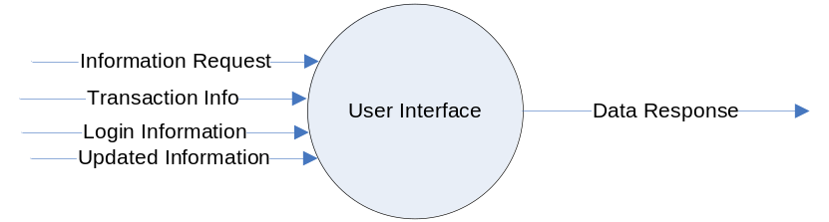
4.1.3 Inputs and Outputs
Inputs
- Transaction information
- Information request
- Login information
- Updated information
Outputs
- Data Response
4.1.4 Functionality
Allows a user of the parking garage to log in, check their usage information, add money to their account, and change their account information.
4.1.5 Performance Issues
The system could run slower if the server is under pressure which could cause delays in updating account information.
4.1.6 Design Constraints
N/A.
4.2 Admin Interface (Web)
4.2.1 Processing narrative (PSPEC)
The administrator interface will be accessible via the web and will allow administrators to add accounts to the database and update the account information.
4.2.2 Function flow diagram
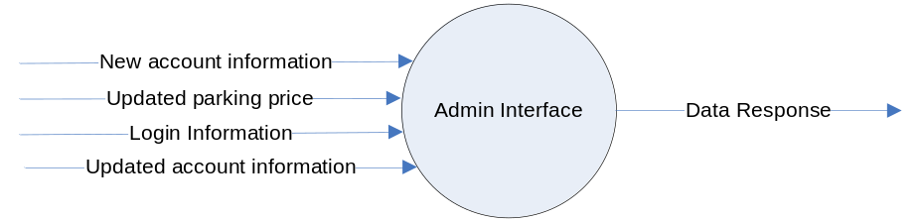
4.2.3 Inputs and Outputs
Inputs
- New account information
- Updated account information
- Updated parking price
- Login information
Outputs
- Data Response
4.2.4 Functionality
Allows the administrators to add new users to the system and update user information.
4.2.5 Performance Issues
The system could run slower if the server is under pressure which could cause delays in updating account information.
4.2.6 Design Constraints
N/A.
4.3 RFID Reader-Database Interface
4.3.1 Processing narrative (PSPEC)
The RFID Reader-Database Interface will be the main way of communication for the RFID card holder to communicate to the database for access into the parking garage.
4.3.2 Function flow diagram
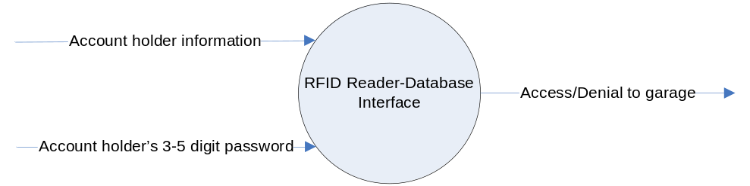
4.3.3 Inputs and Outputs
Inputs
- Account holder information contained on the RFID card
- Account holder’s 3-5 digit password
Outputs
- Access/Denial to the parking garage
4.3.4 Functionality
The RFID Reader-Database Interface allows for communication from the user to the database. If the user has an account and criteria for access are met then they are granted access into the garage.
4.3.5 Performance Issues
Interface from outside sources may possibly cause delays in the request for access to the garage.
4.3.6 Design Constraints
The RFID card must be in close proximity for the RFID reader to pick up the signal and relay the information the database.
4.4 Database System
4.4.1 Processing narrative (PSPEC)
The database system will hold all of the information of every user’s account registered for the parking garage. The Administrator Interface will communicate to the database system if they need to modify a users account.
4.4.2 Function flow diagram
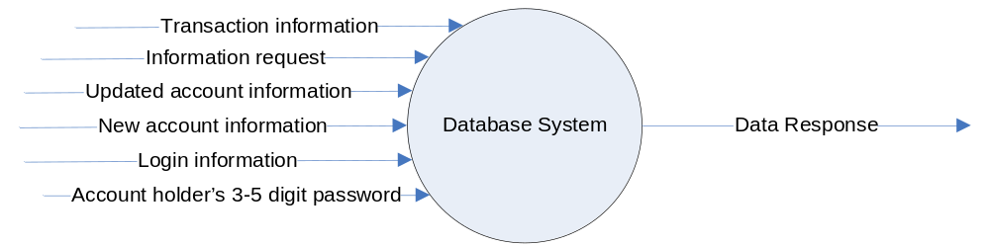
4.4.3 Inputs and Outputs
Inputs
- Information request
- Updated account information
- New account information
- Login information
- Transaction information
- Account holders 3-5 digit password
Outputs
- Data response
4.4.4 Functionality
The database stores all information for the parking garage system including login information for users and administrators.
4.4.5 Performance Issues
Other applications that are running on the same server as the database could potentially cause delays with requests.
4.4.6 Design Constraints
The database design should be simple and easy for modification in the future if changes are needed or requested.
4.5 Software Interface Description
4.5.1 External machine interfaces
We are currently not planning to make an interface to an external machine not contained within our project as this time.
4.5.2 External system interfaces
We are currently not planning to make a system interface for a machine not contained within our project at this time.
4.5.3 Human interface
The web interface will be the human interface for our project. The web interface will allow users to monitor their account by adding funds, changing passwords, check history logs (payment and parking), and make payments if necessary.
4.6 Control flow description
The control flow is presented in section 5.2 of the document which will give an outline of what our system will be expected to provide upon completion.
5.0 Behavioral Model and Description
5.1 Description for software behavior
5.1.1 Events
- User attempts to access the parking garage via RFID card
- User logs into the web interface
- Admin logs into the web interface
- Admin changes users account information in the system
- Admin creates/removes an account
5.1.2 States
- Garage Access Request
- User Web Access
- Admin Web Access
- Idle
5.2 State Transition Diagrams
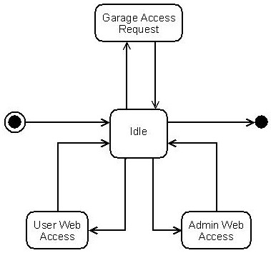

6.0 Restrictions, Limitations, and Constraints
- The system development cost for the initial prototype should not exceed $400.
- The final sales cost should be competitive with other typing products and specialized numeric keypad devices that are on the market at the time of sale.
- The system should be designed for operation in the home, office, or classroom.
- The system should withstand periodic cleaning with a damp cloth and mild detergent.
- The system should not contain materials that are hazardous to the user.
- The system should maintain functionality when used repetitively by elementary school aged children.
- The system should not interfere with the operation of the personal computer to which it is attached.
- The system must comply with Part 15, entitled "Radio Frequency Devices" of Title 47 of the Code of Federal Regulations.
- The system keypad should be ergonomic in design so that the occurrence of repetitive stress injuries is minimized.
- The system must not expose the user to electrical shock.
7.0 Validation Criteria
7.1 Classes of tests
- General Test – User of the simple attempts to access the parking garage via an RFID card or keypad
- Admin Test – An Administrator attempts to login to the system and perform various tasks. (add/remove users, modify user accounts, query database, etc.)
- Web interface Test - A user attempts to login the web interface and modify there account.
7.2 Expected software response
- General Test – System should indicate to the user whether or not they have access and then either grant or deny access to the user
- Admin Test – User information should be modified in the database
- Web interface Test – Users account should be modified according the changes that were made. The new data will be stored in the database.
7.3 Performance bounds
N/A

